Accommodation Website Content
We've got you covered
With strong year-round demand, securing quality accommodation at competitive rates becomes increasingly challenging as your visit approaches. The conference team has done the hard work for you, negotiating exclusive rates and securing a curated selection of well-located options within easy reach of the Host Venue, so you can book with confidence.
Book your accommodation
Not yet registered:
Register & Book now
---------------
Already registered:
Contact Us

Rest Easy and book your accommodation with us:
🪪Security
Book online through our secure booking platform (with no information shared with any third parties)
👍🏼Quality
Our accommodation has been vetted for quality and adherence to the highest standard of guest safety
💲Price
We've negotiated special conference rates that won't be available when the conference starts
👣 Access
Our accommodation recommendations are close to the host venue (within walking distance or easy access to public transport)

Hotel Selection
The rates below are available only to registered RSS 2026 delegates. All rooms and rates below are held until 26 May 2026 or until sold out. Rooms are available on a first-come, first-served basis, so we recommend booking early to avoid disappointment. If you require accommodation outside the official accommodation dates (11 - 18 July 2026), please contact the RSS 2026 SECRETARIAT.

Oaks Goldsbrough
⭐rating: 4
Walking distance to ICC Sydney: 9-minute walk(450m)

Address: 243 Pyrmont St, Darling Harbour NSW 2009

Hotel Description: Oaks Goldsbrough Apartments offer central Sydney accommodation in an architecturally renovated historic landmark building. Situated in the hub of Darling Harbour and combining the charm and elegance of the 1800’s, with all the modern amenities for your business or leisure stay. With a magnificent neo-classical facade, original tallowwood floors, and exposed ironbark columns featured throughout the hotel, as well as views from many rooms over the Sydney skyline and one of its major attractions, Darling Harbour, Oaks Goldsbrough Apartments stands out.

Room Type: Studio- $199 per night
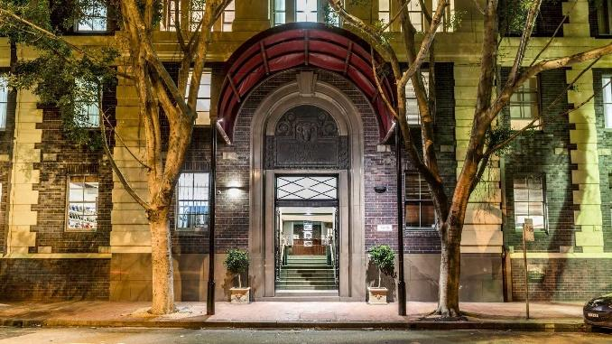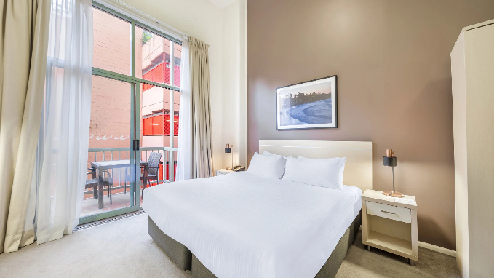

Crowne Plaza Darling Harbour
⭐rating: 4

Walking distance to ICC Sydney: 6-minute walk (500m)

Address: 58 Bathurst St, Sydney NSW 2000

Hotel Description: Enviably located on the corner of Sussex and Bathurst Streets, the Crowne Plaza Sydney Darling Harbour is your sanctuary away from home. Within a 5-minute walk, you can be exploring Town Hall, Queen Victoria Building (QVB), and Sydney’s iconic shopping precinct, the waterside pocket of Darling Harbour with entertainment, museums, incredible wildlife centres, and delicious dining options, including neighbouring Chinatown. We really are in the heart of it all.
Room Type: King Bed Standard- $280 per night

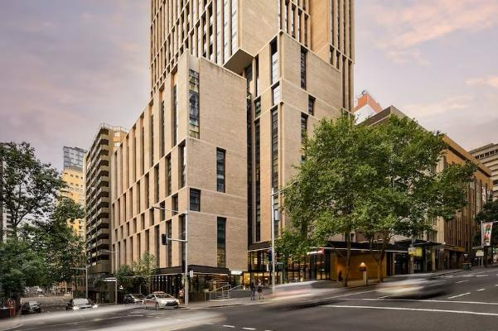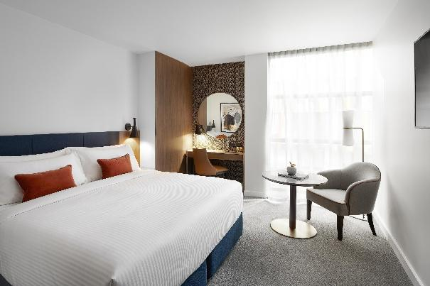

Four Points by Sheraton
⭐rating: 4

Walking distance to ICC Sydney: 19-minute walk (1.4 km)

Address: 88 Broadway, Chippendale NSW 2008

Hotel Description: Stay just steps from Central Station, Chinatown, Darling Harbour, and the CBD. Our contemporary 4-star hotel in Sydney features comfortable rooms, free Wi-Fi, a 24-hour fitness centre, onsite parking, and a casual restaurant and bar. Whether you're visiting for business or leisure, enjoy seamless access to Sydney’s top attractions, dining, and shopping all right on your doorstep.
Room Type: Standard run of house- $280 per night

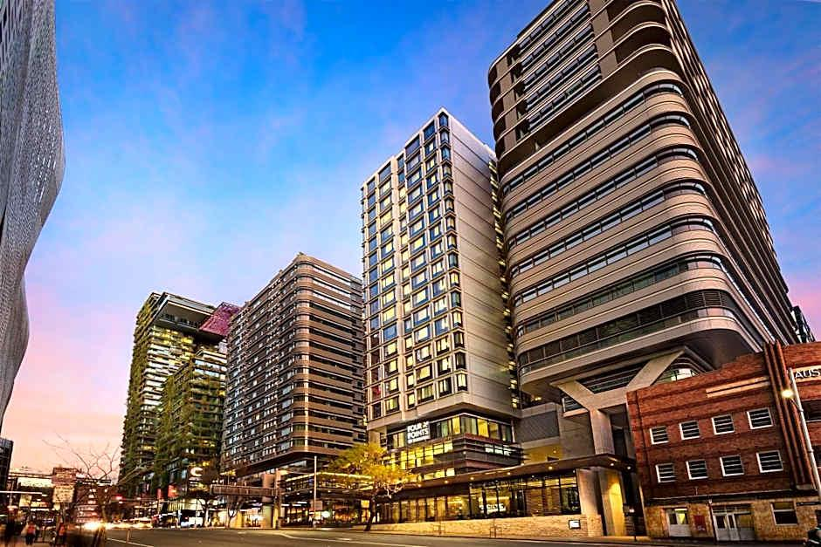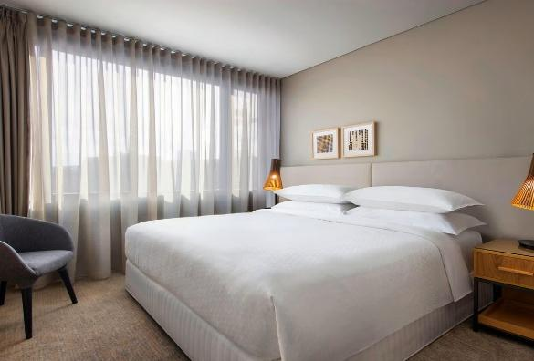

Furama Darling Harbour
⭐rating: 4

Walking distance to ICC Sydney: 5-minute walk (400m)

Address: 68 Harbour St, Haymarket NSW 2000

Hotel Description: Situated adjacent to the bustling Sydney Chinatown and mere steps away from the ICC International Convention & Exhibition Centre, Furama Darling Harbour offers unparalleled accessibility to the city's premier destinations, including Cockle Bay, Sea Life Sydney Aquarium, and Madame Tussaud's Sydney- ensuring that every moment of the stay is filled with excitement and adventure.

Room Type: Standard run of house- $280 per night

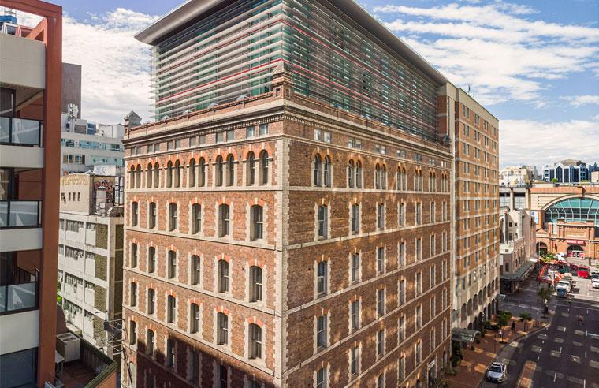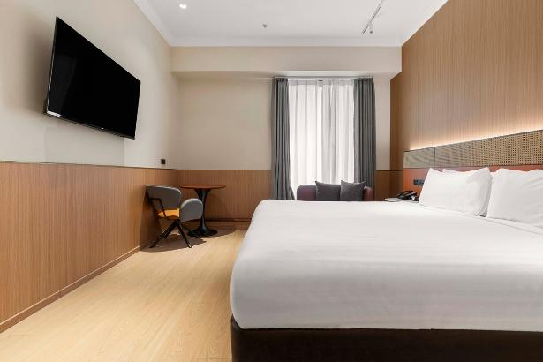

Ibis Darling Harbour
⭐rating: 4.5

Walking distance to ICC Sydney: 5-minute walk (350m)

Address: 70 Murray St, Pyrmont NSW 2009

Hotel Description: Discover modern, affordable accommodation at ibis Sydney Darling Harbour, perfectly positioned in Sydney's vibrant waterfront precinct. Located just 350 meters from ICC Sydney Convention Centre, our hotel offers unbeatable access to Darling Harbour's top attractions, world-class dining, shopping, and public transport connections. Ideal for business travellers attending ICC Sydney events, families exploring Sydney's attractions, and weekend city explorers seeking central accommodation with exceptional value. Unwind in thoughtfully designed rooms featuring the signature Sweet Bed by ibis, complimentary high-speed Wi-Fi, and everything you need for a restful, hassle-free Sydney stay.

Room Type: Standard Room - $290 per night
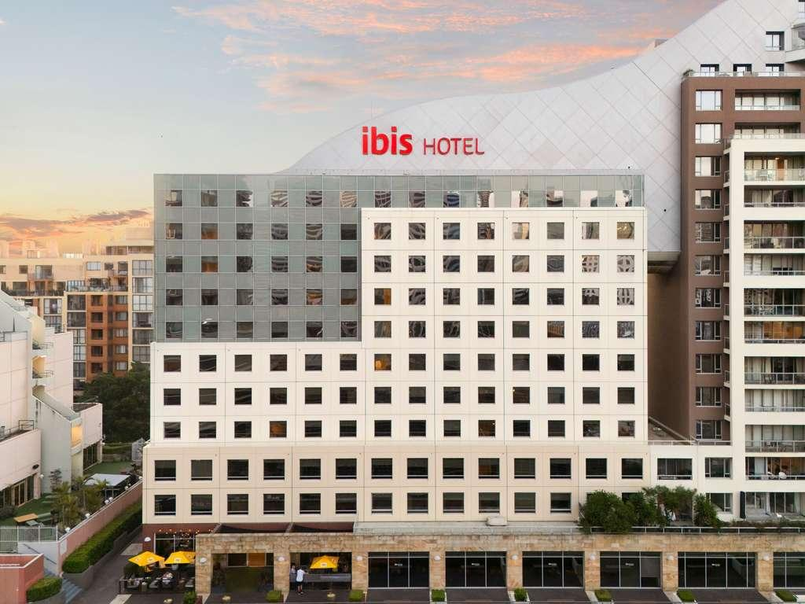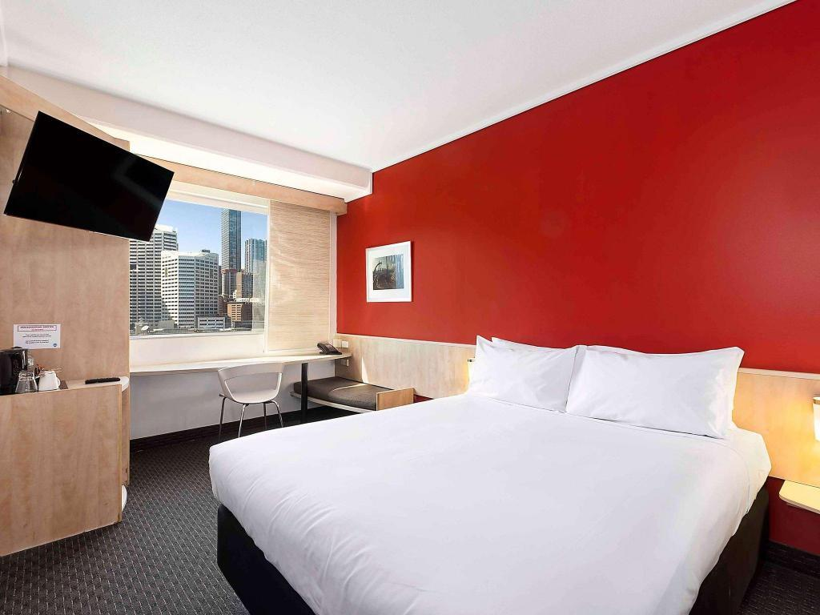

Vibe Hotel Darling Harbour
⭐rating: 4

Walking distance to ICC Sydney: 6-minute walk (500m)

Address: 319/325 Sussex St, Sydney NSW 2000

Hotel Description: The hotel offers guests a new side to Sydney, one that celebrates an eclectic blend of hole-in-the-wall restaurants and world-class sites in proximity. Once you step foot outside the hotel, Sydney’s vibrant CBD will take you on a journey of fantastic flavours and unforgettable moments. Head down to the nearby Darling Quarter for a contemporary vibe that mirrors Vibe Hotel Sydney Darling Harbour’s chic brick-and-wood aesthetic, with a menu to match.

Room Type: Standard run of house $290 per night
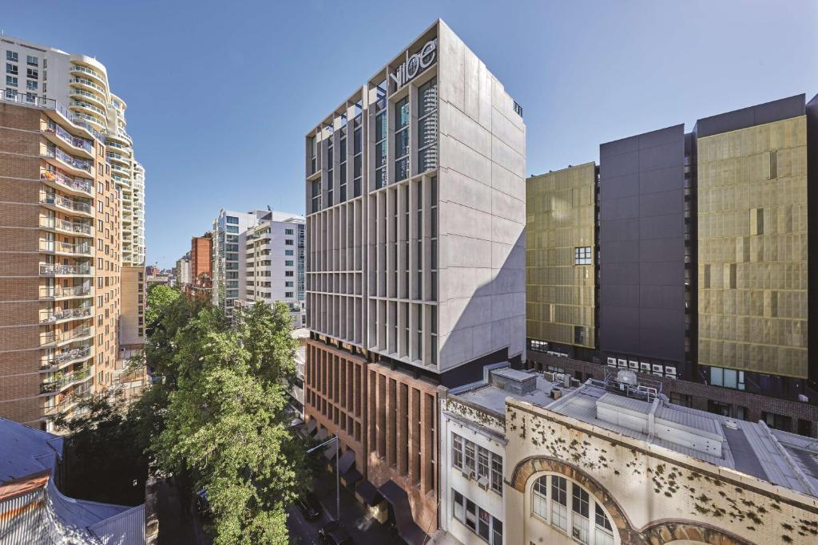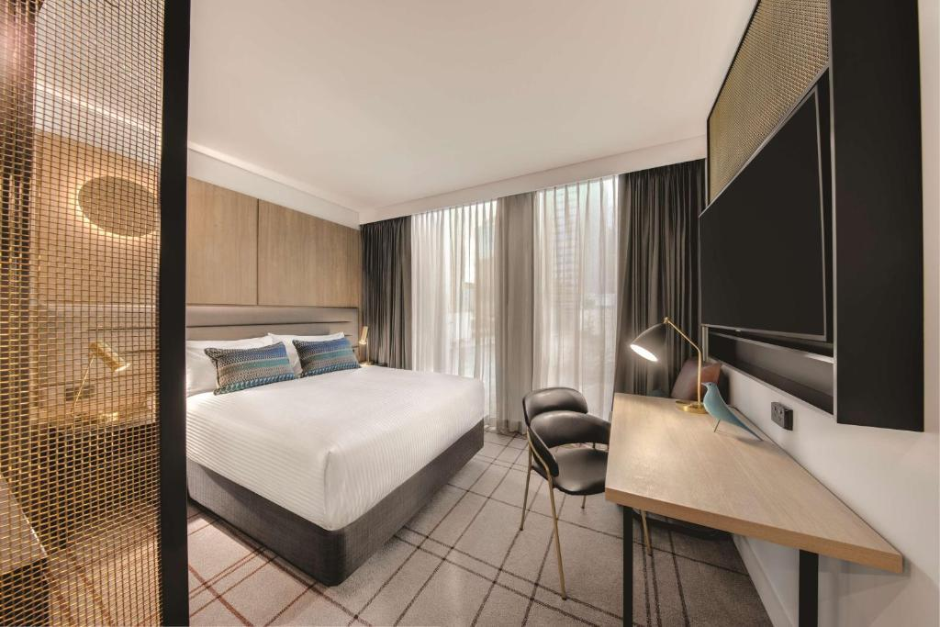

Adina Sydney, Town Hall
⭐rating: 4

Walking distance to ICC Sydney: 7-minute walk (500m)

Address: 511 Kent St, Sydney NSW 2000

Hotel Description: Adina Sydney Town Hall is a stunning, fully refurbished apartment hotel centrally located on Kent Street in Sydney’s CBD. Conveniently adjacent to Town Hall Station, the hotel is within walking distance of the Queen Victoria Building, Pitt Street Mall, Chinatown, Darling Harbour, and Barangaroo.

Room Type:
Studio room – Single Occupancy- $309 per night
One-bedroom apartment- Single Occupancy- $359 per night
Two-bedroom apartment- Double Occupancy- $529 per night

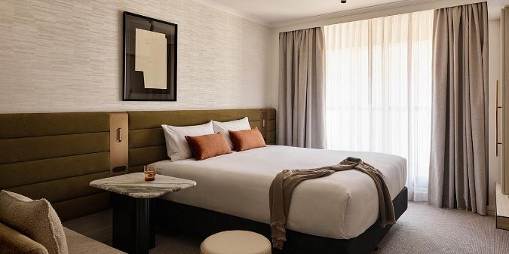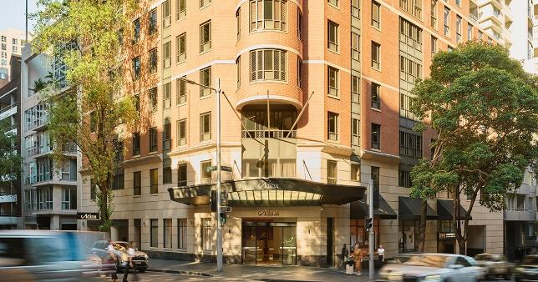

Novotel Darling Harbour
⭐rating: 4.5

Walking distance to ICC Sydney: 10-minute walk (700m)

Address: 100 Murray Street, Darling Harbour, Sydney NSW 2000

Hotel Description: Located in the heart of Darling Harbour, Novotel Sydney on Darling Harbour offers a modern and welcoming experience. The spacious lobby and vibrant design reflect the energy of Sydney, while The Ternary—our signature restaurant, brings together the Grill Kitchen, Asian Kitchen, and Wine Bar in one stylish open space with sweeping views of the city skyline.

Room Type: Superior Room- $320 per night

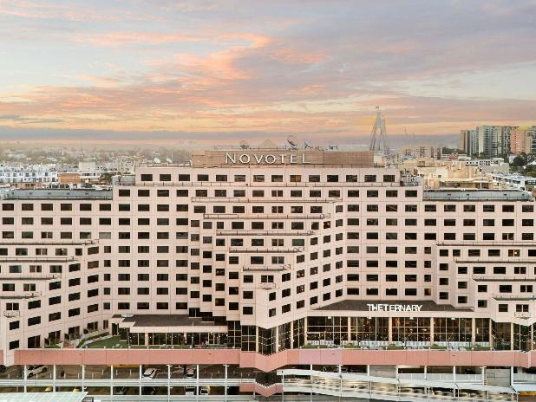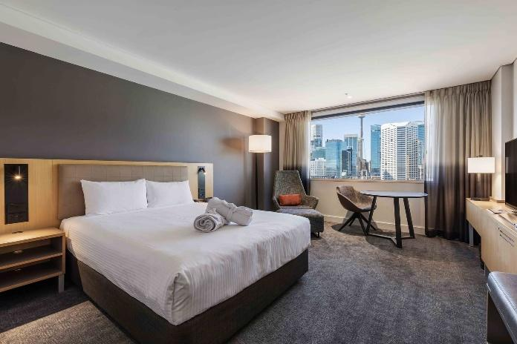

Sofitel Darling Harbour
⭐rating: 5

Walking distance to ICC Sydney: 1 minute walk (opposite ICC Sydney)

Address: Sofitel Sydney Darling Harbour, 12 Darling Dr, Sydney NSW 2000

Hotel Description: Overlooking Darling Harbour, this modern upscale hotel next to the Sydney International Convention Centre is 2 km from the Sydney Tower and a 7-minute walk from the Pyrmont Bay ferry. Relaxed rooms with understated decor and floor-to-ceiling windows offer city or harbour views. Other amenities include free Wi-Fi, flat-screen TVs, minifridges, and tea and coffee-making facilities. Suites add living rooms. Room service is available 24/7. Amenities include 3 chic bars and a heated, outdoor infinity pool, plus a gym and a business centre
Room Type: Superior King Jones Bay View Room- $360
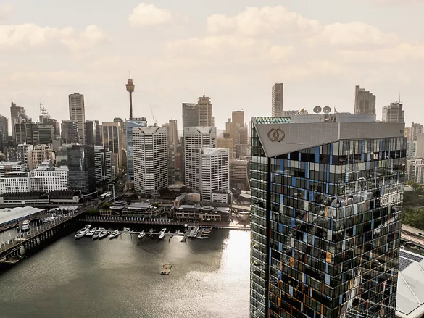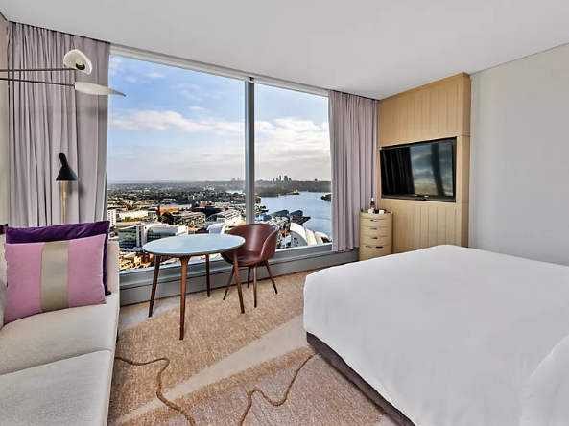

Terms & Conditions
Accommodation Deadline: 26 May 2026

Cancellations
NO ACCOMMODATION PAYMENTS WILL BE REFUNDED ON OR AFTER 26 May 2026. Delegates who confirm an accommodation booking with a credit card or full prepayment and who wish to cancel on or after 26 May 2026 are liable for the full cost of the cancelled accommodation nights. Credit Card details or full pre-payments will be held on file as a guarantee of booking and shared with the hotel in case of no-shows or late cancellations, to charge at the hotel’s discretion. To cancel your reservation, please contact the RSS 2026 Secretariat. Name changes to a reservation can be made at no charge.

Deposits
Accommodation will not be confirmed until payment for the first night is received by Credit Card, or full prepayment is received by Cheque or Electronic Funds Transfer. Your payment will be forwarded to your hotel and credited to your room account, and credit card details will be retained on file as a guarantee of booking. Delegates must settle the balance of their account with the hotel concerned upon check-in/out, depending on the hotel's policy. If accommodation deposits are not received before 26 May 2026, your room will be cancelled and released back to the hotel. The RSS 2026 Secretariat does not take responsibility for accommodation if payment is not received by this date.

Change of booking
Any change in booking must be made in writing to the RSS 2026 Secretariat and NOT directly to the hotel before 26 May 2026. Any changes received after 26 May 2026 will be at the hotel's discretion and subject to availability.

Early arrival
As check-in at most hotels is not until 14:00, your room may not be ready for immediate occupancy upon your early arrival. Whilst hotels will do everything possible to accommodate early arrivals, if you wish to be guaranteed immediate occupation, you can pay an extra day’s tariff for the night before you are due to arrive. If you wish to take this precaution, please advise the RSS 2026 Secretariat so we can notify the hotel that your room is required early.

No-show policy
In the event of a “No Show” on the date of arrival, full cancellation penalties apply to all nights of the stay.

Enquiries
Please direct all enquiries to the RSS 2026 Secretariat:
Registration & Accommodation Enquiries
P: 03 9682 0500
E: rssconference.reg@gmail.com

